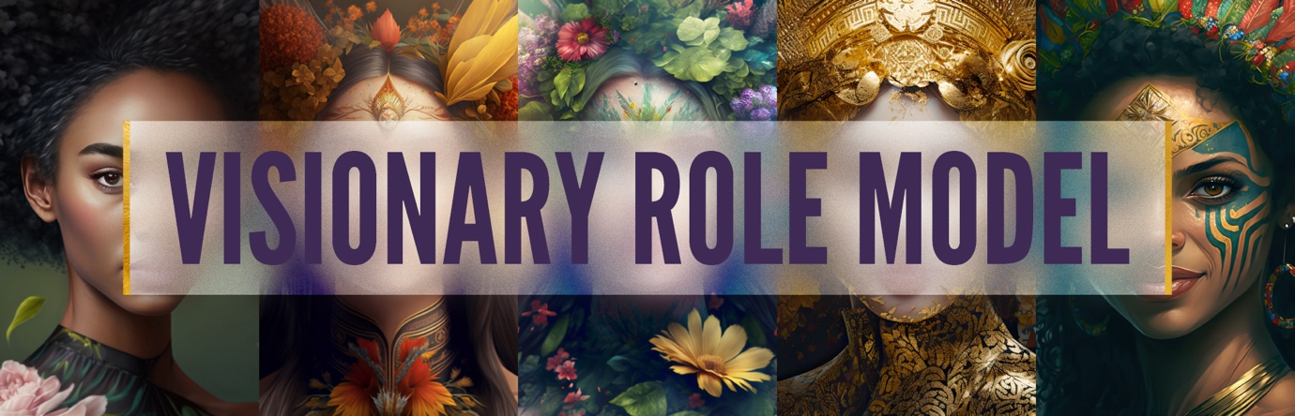
APPLICATION FORM

Instructions: Simply type into this document directly, making sure everything is saved successfully before emailing your completed form to diana@karenknowler.com.

Today’s date:

Your name:

Town/city & country:

Best email address:

What line of work/service are you currently in and/or want to move into?

Why did you start your business?

Where are you at currently in your business journey?

What is your why for doing what you do?

If you have a website, what is its URL?

How would you best summarise your personal development journey to date in one succinct paragraph?

Where do you want to go personally AND professionally? Please share at least 2 goals for each and why these goals.

Why have you chosen to apply for the Visionary Role Model program?

Why is NOW the time for you to step into this level and depth of work?

On a scale of 1-10, how committed are you to “doing the work” personally and professionally, to step into your next level of mastery?

Please say more about the answer you gave above.

Anything else you would like share?

Please read the following and only submit your application when all of the below are true for you:

- You have read the entire program brochure.
- You are available to speak with Karen within the next 72 hours.
- After speaking with Karen, and if you were to be offered a spot in the program, you will be ready to make your investment and schedule your 1:1 call with Karen at the end of your conversation.
- You are in a position to invest in this program, whether it be pay-in-full via a payment plan, without undue stress.
- You understand that this is a 12-month program and is 100% virtual.

Please send your completed Application to diana@karenknowler.com with Visionary Application in the subject header and Diana will respond to you very soon to set up a time to speak.

